Diffusion optics project -- process overview
This document walks through the full project, from tissue generation through wavefront correction to speckle statistics, for course submission. The accompanying submission/ folder contains a runnable copy of the final analysis (main.py + functions.py).

1. Goal and model
The project simulates multi-plane wavefront shaping (MWFS): a scattering tissue is approximated as M thin phase-only "aberration planes" separated by free-space propagation, and a corresponding set of conjugate-phase "correction planes" (as would be applied on an SLM) attempts to undo that aberration and refocus a point source. Each plane A_k is built from a generated 3D tissue volume as A_k = exp(i*angle(mask_f(:,:,k))) -- phase-only, unit amplitude. Propagation between planes uses the exact (non-paraxial) angular spectrum method, with evanescent spatial-frequency components dropped -- a physically necessary step (those components don't propagate in free space at all), not an approximation, for any propagation distance much larger than a wavelength.

2. Tissue generation and a real averaging bug
The 3D tissue (tissue_3d_generator.m) is a random field of spherical scatterers, downsampled from a fine (x_stp-spaced) z-grid into M coarse aberration planes by averaging. The original downsampling loop used a fixed tolerance (x_stp*0.75) to decide which fine layers belong to each coarse plane -- but that tolerance doesn't scale with the plane's intended thickness, so it only ever caught 1-2 fine layers, turning every "plane" into a thin ~0.1-0.2um slice instead of a genuine average over the full slab. Fixed by scaling the tolerance to the bin half-width (h_z_stp) with a small floating-point epsilon, matching the file's existing epsilon convention elsewhere. Verified directly in the generation log: each bin now catches exactly the intended number of fine layers (e.g. 75 of 75), tiling the full tissue depth with no gap or overlap.
A consequence worth noting: with the fix, for M=2 planes, plane A's averaging window is the tissue's entrance half (forward z in [0, Z/2]) and plane B's is the exit half ([Z/2, Z]) -- contiguous halves of the full depth, not arbitrary thin slices. This mattered directly for the capillary/RBC scenarios below: a capillary centered at the tissue's z-midpoint straddles exactly the boundary between the two planes' windows, so both planes get a meaningful share of it.

3. Sim step 1: ideal correction, static tissue
For a static (non-flowing) M=2 tissue, the correction planes are taken as the exact conjugate of the aberration planes (A~=conj(A), B~=conj(B)) -- "ideal" knowledge of the aberration. The full sequence is:
u_in -> propagate(eps) -> xA -> propagate(eps) -> xB -> xB~ -> propagate(-eps) -> xA~ -> propagate(-eps) -> u_out
u_in is a single point source at the center of the field. Because A~ and B~ exactly invert A and B, u_out refocuses back toward u_in -- limited only by the diffraction limit (the evanescent components discarded during propagation can never be recovered by any phase-only correction, since that loss is a non-invertible projection, not a phase error).
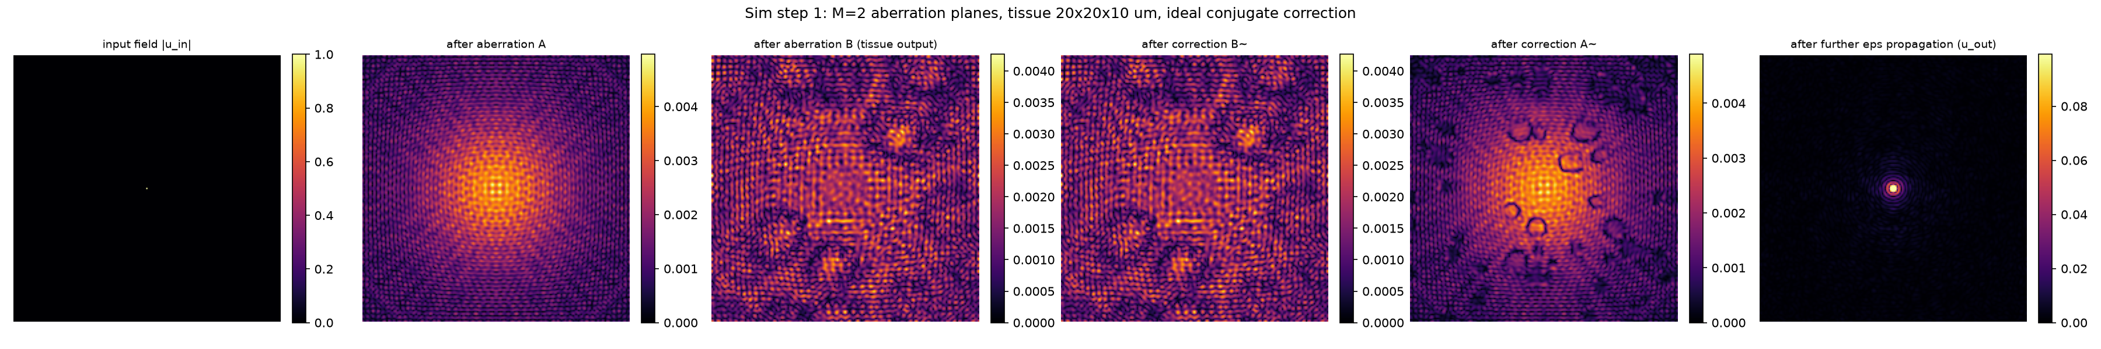
Figure: input field, field after each aberration plane, field after each correction plane, and the final refocused u_out (20x20x10um tissue, M=2).

4. Sim step 2: a flowing capillary with red blood cells
The static tissue is extended with a capillary (blood vessel) carrying red blood cells (RBCs), to model a tissue that changes over time. The capillary's axis runs along Y (lateral, not the z/propagation axis) -- its stated diameter is a circular cross-section in the X-Z plane, uniform across the tissue's full Y-extent. Diameter oscillates sinusoidally: diameter(t) = 7 - 3*cos(2*pi*t/8) um (4um contracted at t=0, 10um dilated at t=4s, 8s period). Each RBC is modeled as a box, square in cross-section (intersected with the tube's circle so it can't poke past the vessel wall), with width, length and speed all scaling linearly with the instantaneous diameter: width 4->8um, length 10->12um, speed 8->25um/s. The empty capillary ("plasma") is the literal value 1+0i; an RBC voxel is exp(i*2*pi*0.38) -- Delta_n=0.38 (RBC refractive index 1.38, plasma index 1) applied directly as phase-in-cycles, matching how the background spheres' own phase is built (no separate path-length term in either case).

4.1 Single RBC
A first, simpler scenario: one RBC starts at the tissue's entrance edge at t=0 (already present, not gradually entering) and flows through over 4 timesteps (1 second, 4Hz sampling). Both the capillary and cell dynamics follow the formulas above.
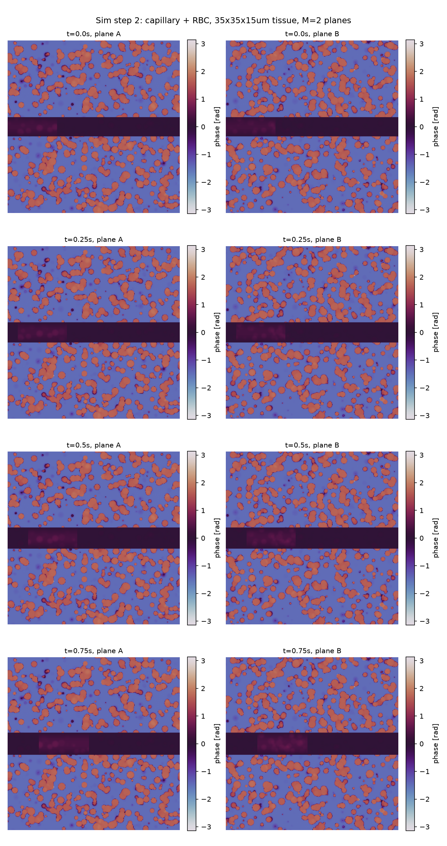
Figure: phase of aberration planes A, B across the 4 timesteps -- the capillary appears as a horizontal band (Y-axis oriented tube, localized in X, spanning the image in Y), and the RBC is visible as a distinct patch moving left to right (into the tissue) within it.

4.2 Two RBCs, gradual entry/exit
A more elaborate scenario: the capillary starts genuinely empty at t=0. RBC 1 gradually enters (its leading edge starts at the tissue boundary and advances -- only part of the cell is visible while crossing the boundary, growing to full length once fully inside, symmetrically shrinking on exit). RBC 2 begins entering once RBC 1's leading edge reaches the tissue's Y-midpoint ("halfway through", spatially -- not a fixed elapsed time, since speed varies with the capillary's dilation). Both cells share one capillary; recording continues at 0.25s steps until both have fully exited -- this produced 17 timesteps (t=0 to 4.0s), computed, not fixed in advance.
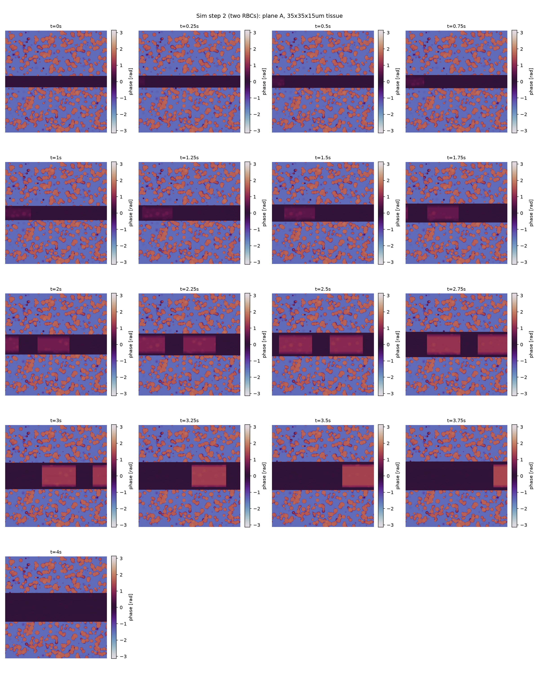
Figure: aberration plane A's phase across all 17 timesteps. RBC 1 grows in from the left starting at t=0; RBC 2 appears (also growing in) starting around t=2s, right on schedule for when RBC 1's leading edge crosses the midpoint; RBC 1 shrinks out around t=3-3.5s; RBC 2 shrinks out by t=4.0s, leaving the band empty again at the final frame.

5. Sim step 3: a correction that goes stale
Step 1's correction assumed perfect, continuously-updated knowledge of the aberration. Step 3 asks a more realistic question: what if the correction planes are calibrated ONCE (from the t=0 snapshot, empty capillary) and then applied UNCHANGED as blood actually flows through the two-RBC tissue from step 4.2? A~=conj(A(0)), B~=conj(B(0)) are fixed; the forward aberration at each timestep, A(t) and B(t), is the timestep's ACTUAL state:
u_out(t) = P(-eps)@A~ @ P(-eps)@B~ @ B(t) @ P(eps)@A(t) @ P(eps) @ u_in
A second pipeline (uncorrected baseline) propagates through the same A(t), B(t) but backpropagates 2*eps in one step with no correction planes applied at all, for comparison.
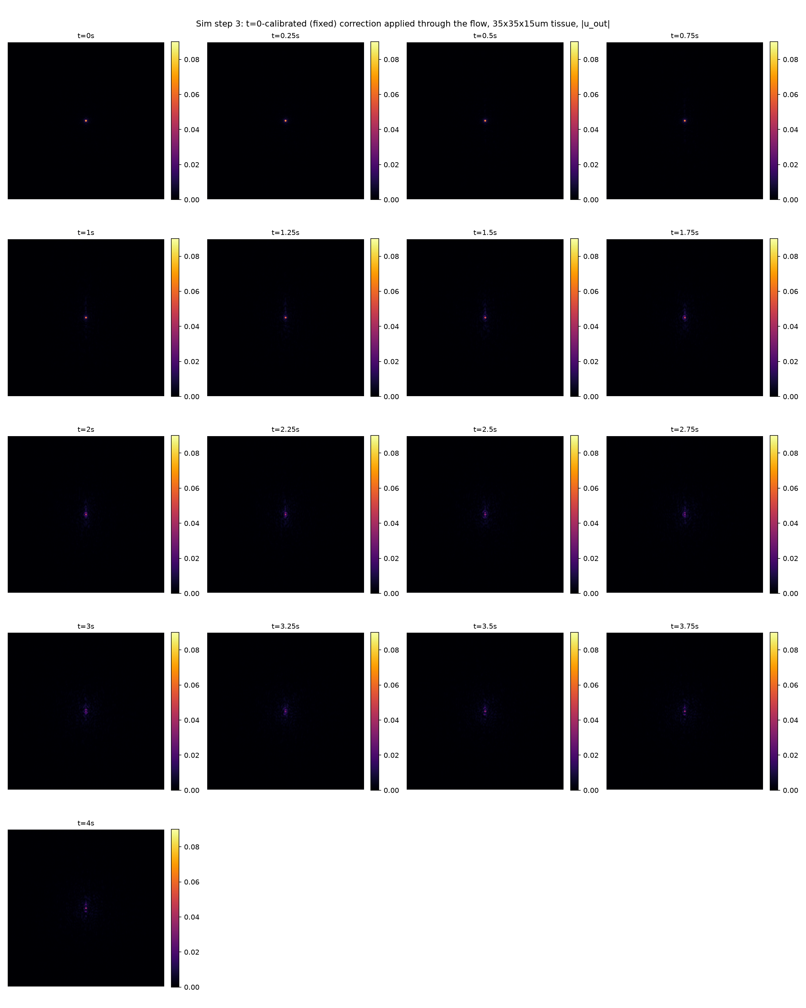
Figure: |u_out(t)| for all 17 timesteps, corrected path, one shared color scale (referenced to t=0's own peak -- the best-case result, since the fixed correction is exact only there). t=0 is a clean, tight, diffraction-limited spot; as RBCs actually flow through (t=1s onward), a residual streak grows where the stale correction can no longer cancel them, most pronounced around t=2-2.75s when both cells are simultaneously present.

6. Speckle correlation statistics: g2(tau)
Per course_material/"8. Laser speckle contrast imaging and multiple scattering theory2.pdf": the field autocorrelation g1(tau)=<E(0)E*(tau)>/<|E(0)|^2> and, via the Siegert relation, G2(tau)=<I(0)I(tau)>=<I>^2+beta*|G1(tau)|^2. We compute the intensity autocorrelation g2(tau) directly for the corrected output series u_out(t), using a SPATIAL average (not a temporal average over multiple (t,t+tau) start-time pairs):
g2(tau) = <I(0)*I(tau)> / <I(0)^2>, I(t) = |u_out(t)|^2
where <...> is the mean over all pixels of the element-wise product, referenced to the t=0 frame. A field correlation g1 was deliberately not attempted this way: spatially averaging the complex field E(0)[x,y]*E*(tau)[x,y] over many independent speckle grains (each with essentially uncorrelated absolute phase) mostly cancels out and isn't physically meaningful without a common phase reference across the image -- exactly why real camera-based speckle imaging works with intensity, not field, statistics (a camera only ever records |E|^2).
A normalization bug was found and fixed during this analysis: the denominator must be the numerator's OWN value at tau=0, i.e. <I(0)*I(0)>=<I(0)^2> (mean of I0 squared) -- not <I(0)>^2 (mean of I0, then squared). The two coincide only for a spatially uniform I(0); for our highly-peaked corrected field they differed by a factor of several thousand. With the fix, g2(0)=1 exactly, by construction (numerator and denominator are the same expression at tau=0), matching the equivalent identity g1(0)=1.
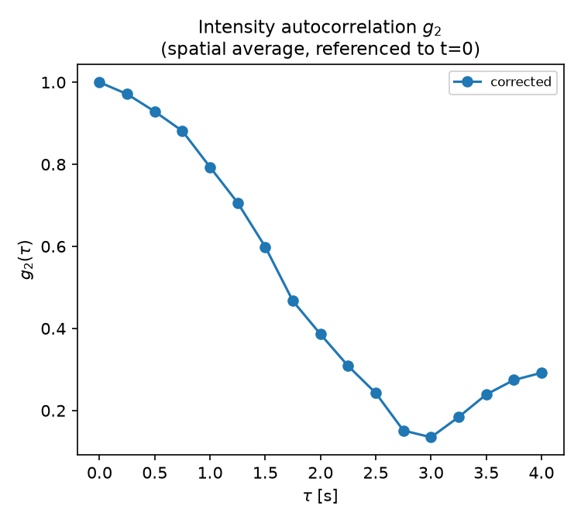
Figure: g2(tau) for the corrected path (uncorrected path intentionally left out of this plot for now).

Why g2 decreases, then increases again
g2(tau) decays from 1.0 (t=0) down to a minimum around tau~2.75-3s, then rises back up to ~0.29 by tau=4.0s. The reason for the increase in correlation is that the RBCs leave the FOV (field of view): by t=4.0s, both red blood cells have fully exited the capillary -- the tissue returns to a state much closer to its (RBC-free) t=0 configuration, so u_out(tau) partially re-correlates with u_out(0). The minimum around tau~2.75-3s corresponds to when the RBC presence (and thus the aberration mismatch against the fixed, t=0-calibrated correction) is greatest.
Note that g2(tau) is not mathematically bounded by 1 for tau>0 -- only g2(0)=1 is guaranteed, since the normalization is anchored solely to the t=0 frame rather than symmetrically to both frames. By Cauchy-Schwarz, g2(tau) <= sqrt(<I(tau)^2>/<I(0)^2>), a bound that can exceed 1 whenever frame tau has more spatial contrast than the reference frame -- this was confirmed numerically to hold at every recorded timestep.

7. Submission folder
submission/main.py is a copy of the final step-3 analysis script; submission/functions.py consolidates every function/constant it imports, directly or transitively, from the full project's step_one.py, step_two.py and step_two_two_rbcs.py modules -- so this folder is self-contained (two files) without needing the full project's module structure.
The generated tissue data (capillary_system/tissue_background_35x35x15_two_rbcs.mat -- the aberration/correction plane data, ~500MB) is NOT included in this submission.
To actually run main.py, that file needs to be regenerated (via the project's MATLAB pipeline: tissue_3d_generator.m, called from capillary_system/run_tissue_3d_generator_capillary_35x35x15_two_rbcs.m) and placed at submission/capillary_system/tissue_background_35x35x15_two_rbcs.mat. submission/main.py was verified to import cleanly and fail ONLY on the missing data file (FileNotFoundError at the load_background call), confirming the code itself -- imports, function wiring -- is correct and complete.

